My project is called the Back Alley Pizza Trials. Originally it started out as an idea for a game between a user and another game character or another person. What it ended up being was an odd interaction site. 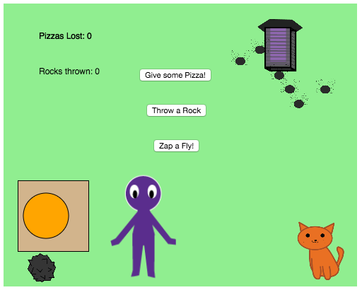

The purple person is supposed to be the user. The circle is the pizza, which if you press the button, gives some pizza to the cat. It throws pizza at it and once it passes the cat, the cat makes a “meow” sound. After all five of your pizzas are given to the cat, then you die of starvation.

If you press the “throw a rock” button, it throws a rock at the cat. After three rocks are thrown, the cat kills you and “you’re dead” shows up on the screen.

When you zap away the flies

they all die.

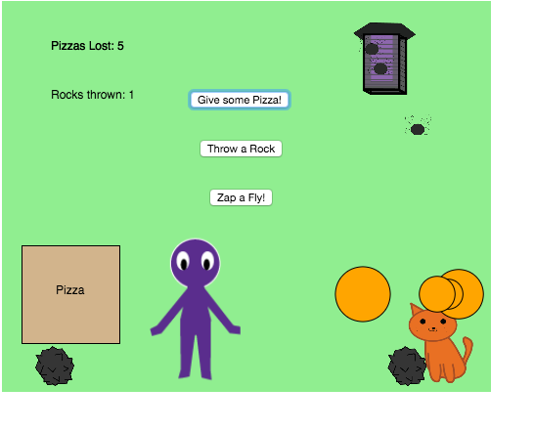

I worked with the dom library because the play library was not working the way I wanted to. I’m glad I accomplished the odd interactions that I was looking for, and if I had more time, I would have included more. I would have tried some camera functions, and made more things happen that move around with other characters. On the bright side, the sounds came out pretty nice. I recorded them all from my classmates, Devon, Brendan, and Sean. Devon was the meow, Sean was the rawr at the end of the throwing rock, and Brendan was the hissing and the zap.

I’m really glad this showed me how to use buttons and interactions of such. I hope to do more with it.